*Owen Lindsey*

*Professor Sparks, James*

*CST-391 Activity 4*

*11/03/2024*

**Screenshots of Music App**

*Main application home page:*   
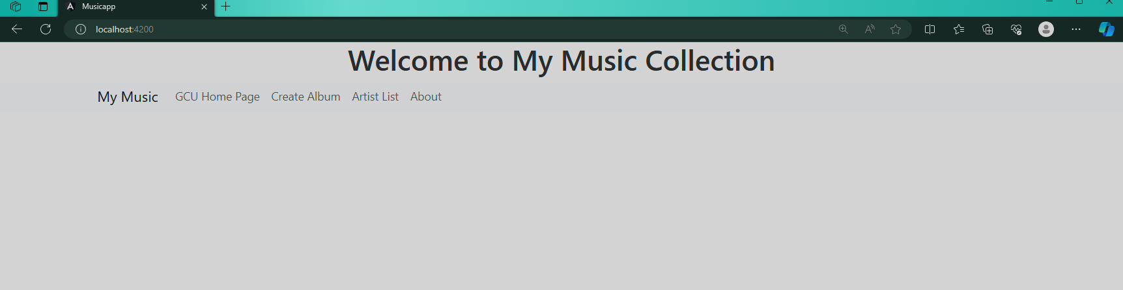

*Artist list page:*   
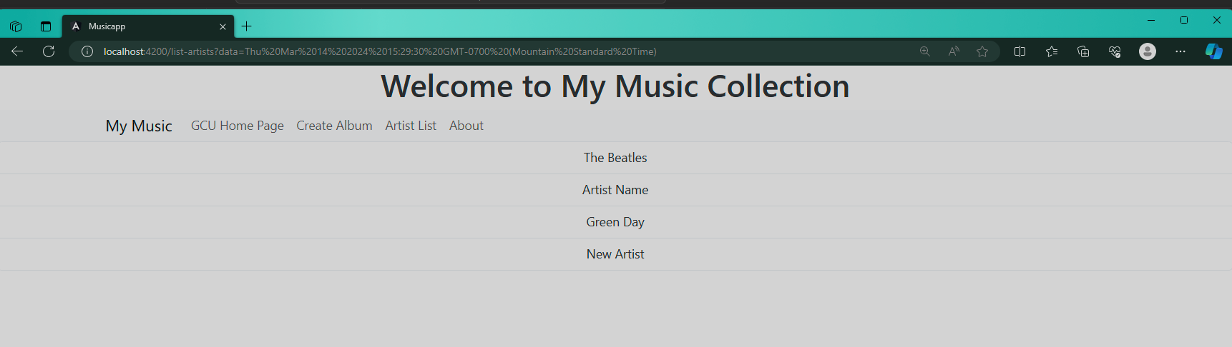  
  
*Album list page:*  
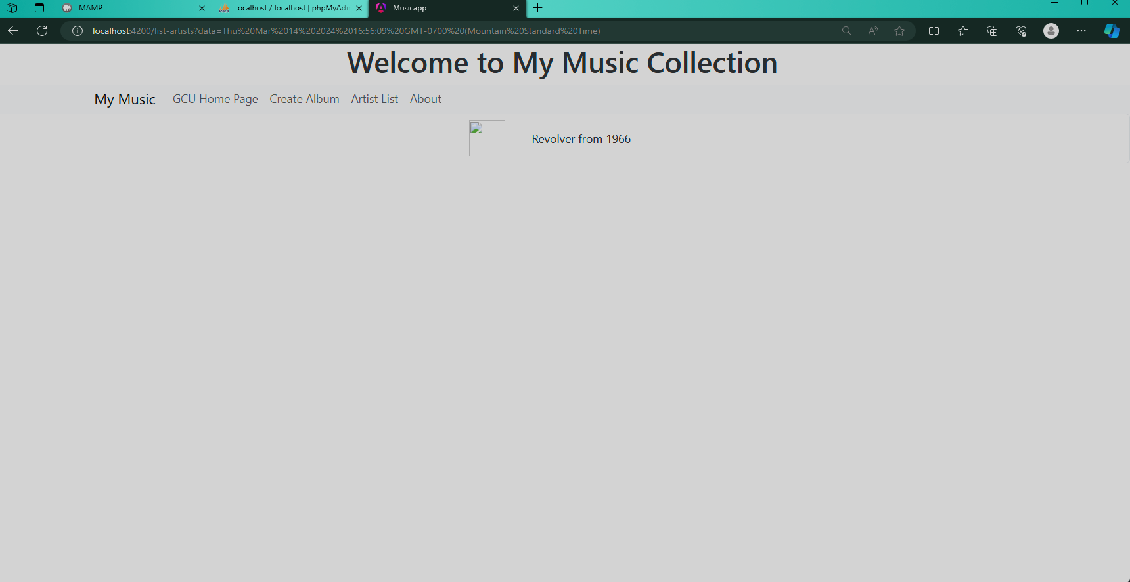

**Screenshots of Music App**

*Album display page:*

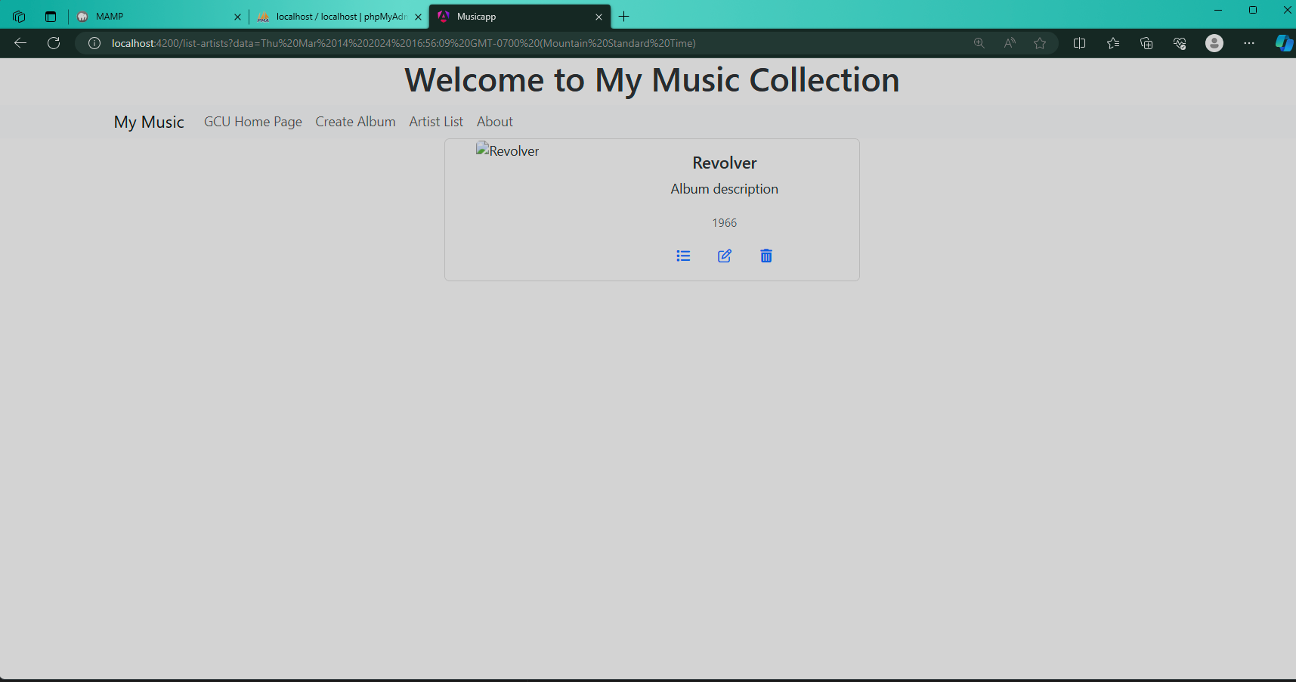

*Add album input page:*  
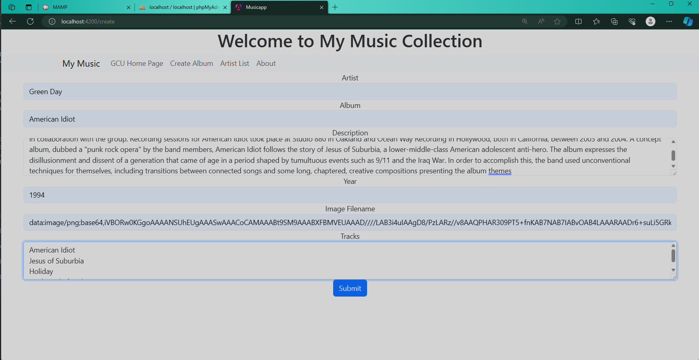

*Add album success page:*  
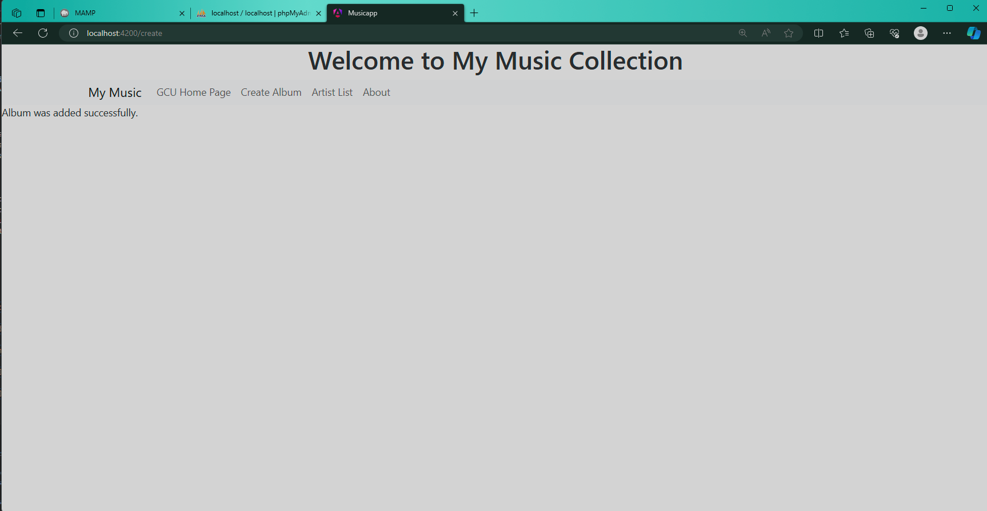

*Edit album page with input:*   
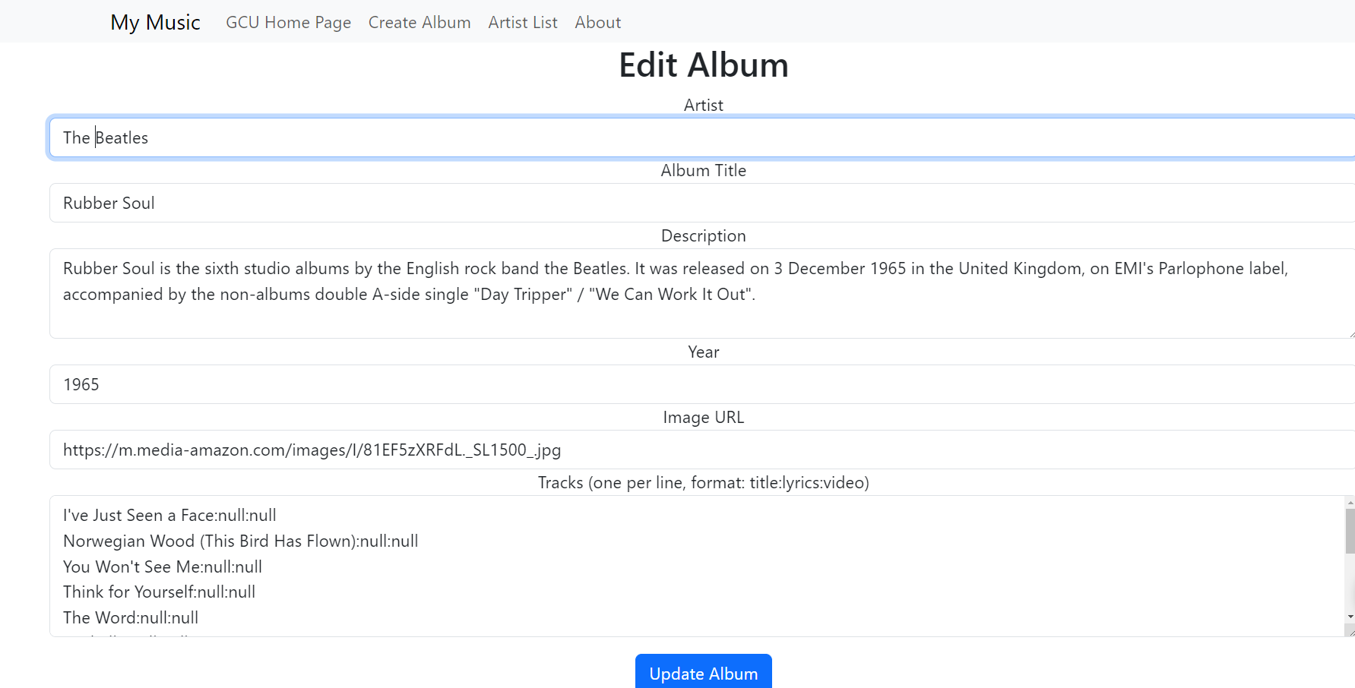

*Edit ‘The Beatles’ to ‘Beatles’:*  
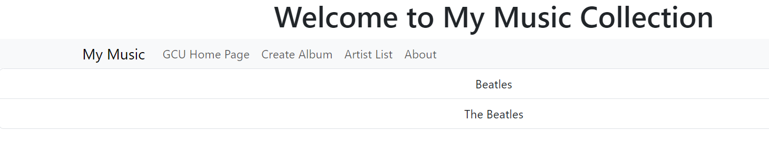

*Delete album confirmation page:*  
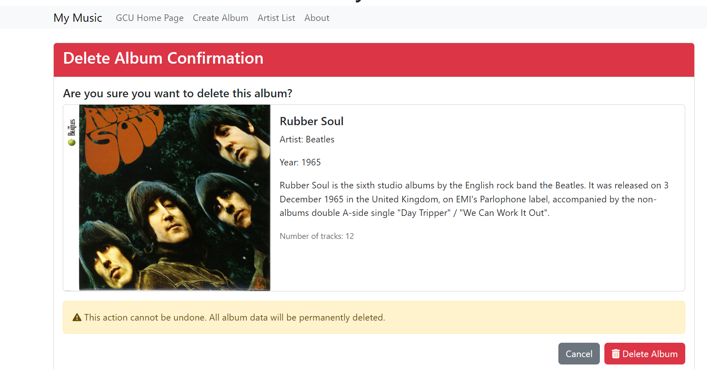

*Delete album successful Rubber Soul is now removed:*  
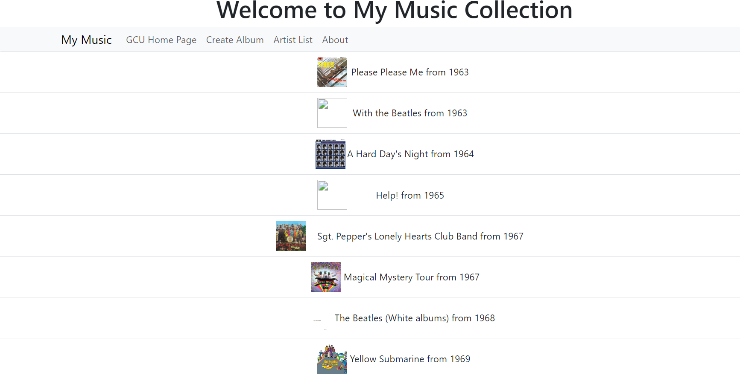

**Angular Authentication and Session Management**

***Authentication implementation:***  
1. Auth.service.ts - Core Authentication Service  
 *- Manages user authentication state.*

*- Handles JWT token storage and retrieval.*

*- Implements login/logout functionality.*

*- Contains token refresh logic.*

2**. auth.interceptor.ts** - HTTP Request Interceptor

*- Automatically adds authentication token to requests.*

*- Handles unauthorized responses.*

*- Manages token refresh.*

3. **auth.guard.ts** - Route Protection

*- Protects routes from unauthorized access.*

*- Redirects unauthorized users.*

*- Validates authentication state.*

***Implementation Details:***

1. **Authentication Process**

* *Server validates credentials.*
* *Issues JWT token upon successful login.*
* *Token stored in localStorage / sessionStorage.*

1. **Session Management**

* *Token included in HTTP headers.*
* *Server validates token per request.*
* *RxJS Observables track auth state.*

1. **Security Considerations**

* *HTTPS is required for secure transmission.*
* *Token expiration handling.*
* *Refresh token implementation.*
* *Secure storage practices.*

1. **State Communication**

* *HTTP interceptors for request headers.*
* *Observable pattern for state management.*
* *Server-side token validation.*
* *Automatic token refresh mechanism.*

1. **Logout Handling**

* *Token removal from storage.*
* *Server-side token invalidation.*
* *State reset in application.*
* *Route redirection.*